

**Instructor: Braden Caywood**

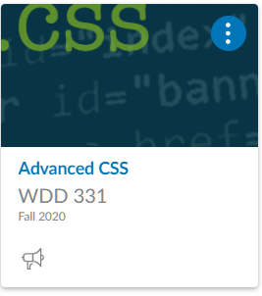

**ADVANCED CSS-WDD331**

David Hinbest-Scott Moscarello- William Meza Figueroa

WDD331 - Fall Semester

October 10th, 2020

**W04: Group Project Zen Garden**

1. The names of all members of the group: David Hinbest, Scott Moscarello, and William Meza Figueroa
2. The theme we have chosen and ideas about how you will incorporate it into your design: Our webpage will be a mix of the rule of thirds and the ZenGarden site called “[Screen Filler](http://csszengarden.com/217/)” by [Elliot Jay Stocks](http://elliotjaystocks.com/).

**Scott:** suggest getting a clean site built first and then if there is extra time try to tweak it for an extra umpft.

**Dave:** Looking at the designs of most other sites I find them very hard to read. I wonder if we style ours for readability and understanding of the main concepts of ZenGarden

**William:**  we can even make a mix between these, I would like to make a clean design and work on it.

1. images of at least two wireframes:

